

|  |
| --- |
| Audit & Ethical Hacking |
|  |
| 30 March 2020  Bucharest University of Economic Studies  CSIE Faculty, IT&C Security Master Program  Authored by: Ionescu Radu Ștefan |



# Social Engineering - User credentials generation

## Known user information



Image 1 Popescu Ion

First name: Ion

Last name: Popescu

Hometown: Daia, Giurgiu, Romania

## Further information gathering

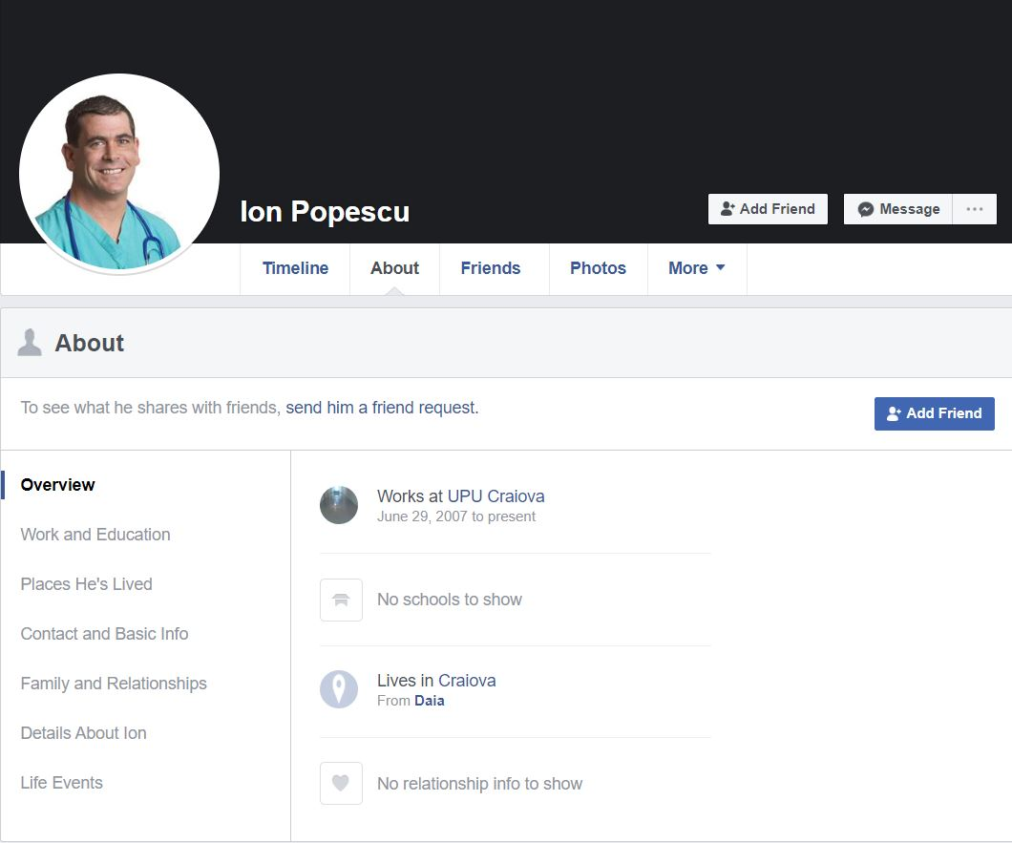

Image 2 Popescu Ion Facebook Page

Source: Facebook Profile Page

Current city: Craiova

Work: UPU Craiova

Facebook page: <http://facebook.com/ionPopescu86>

Possible birth year: 1986

## Possible emails and passwords generation

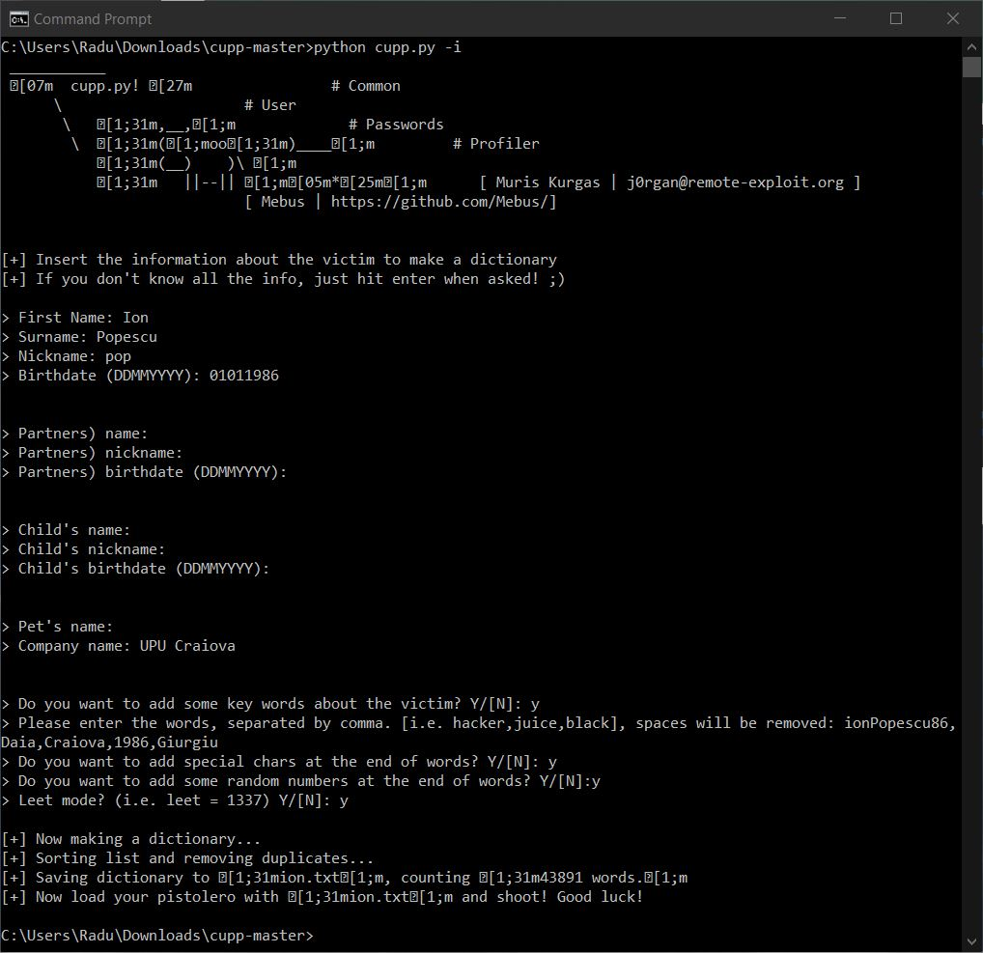

Image 3 cupp tool

Creating a dictionary for our target user, Popescu Ion, using the Common User Passwords Profiler (cupp) tool from Mebus. Using all the gathered information, by feeding it to the cupp tool, we create a dictionary for Popescu Ion, containing 43,891 words, saved in *“ion.txt”* file. Then we use this dictionary with Mentalist and some rules, like adding something before or after the words, modifying letter case and substituting some characters with others, to generate another, bigger word list for our target.

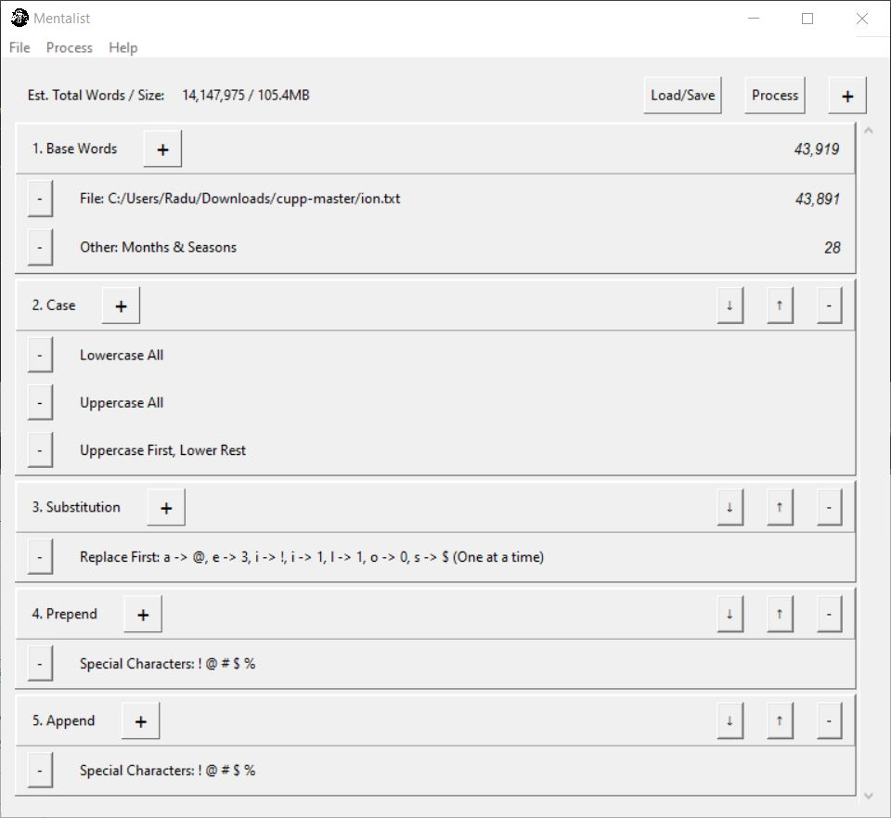

Image 4 Mentalist tool

The Mentalist tool generates a list of 3,648,750 words, saved as *“ion_mentalist.txt”*. We will use this big list to extract the best 100 candidates for the email and for the password.

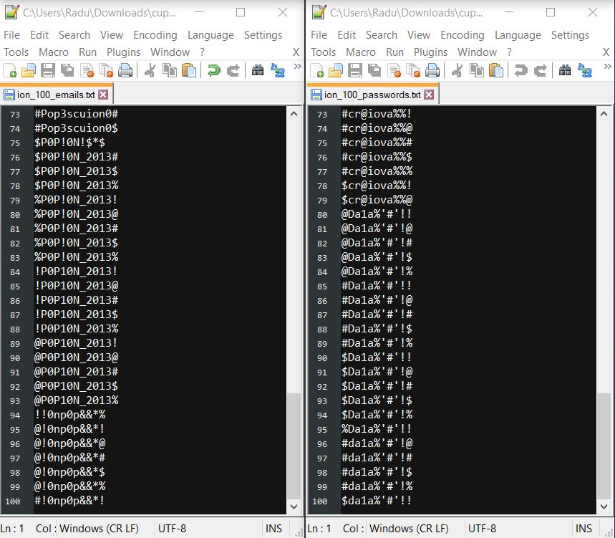

Image 5 Final list of emails and passwords